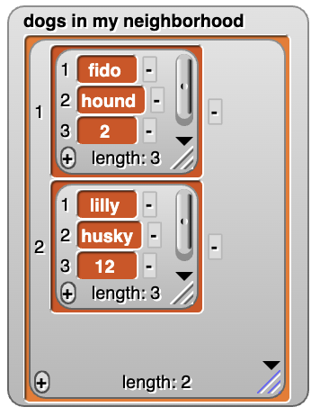
Beauty and Joy of Computing Unit 3 Assessment
Similar to your work in Lab 3: Turning Data into Information, create a data project that meets all of the following specifications:
- Stores and manipulates information by creating an abstract data type that uses lists within lists to store similar data about several different items.

For example, you can store the name, breed, and age of several dogs as shown in the image to the right.

- Includes ways for the user to do the following:
  - Add new items to the list.
  - Clear the list.
  - Search the list for an item that meets a specific criteria. For example, a dog with a given age.

